INTRODUCING Java

class
Every java program contain atleast one class. Which is :
public class NameOfClass
{
code block
}
- Here:
➢ public keyword allow us to access the program file(it’s methods) in other program files.
➢ Class is the container of methods and objects. So , there must be atleast one class that can hold our methods.
➢ NameOfClass is the name of class written in pascal case convention. Name is of programmer choice.
- Pascal case is used for classes only . It syntax is the every word starts with a capital letter. Example: CupOfTea , JarOfBeans .
- Writing with this syntax is recommended . Its on programmer choice too use any case.
- Example of classes in java ,
1) System.in
2) String .
3) System.out
- //String and System is a class , for the sake of argument >Pascal case is only with classes .

Method
- There is a special method in every program that auto runs when programs is used which is “main” .
- Method contains the programmer coding, its only writtenable inside a class .
- We can’t create a method inside a method, but we can create multiple methods inside a single class.
- main method is must for executing program , we can create different methods but those must be called/used in main method in order to use them.
public class NameOfClass
{
public static void main(String[] args) // its the main method which allow execution
{
code block
}
public static return_type nameOfMethod() /*its the method which take values and prints in
{ some order ,or take values and solve them for user and
code block returns a value of a specific type,will be discussed*/
}
}
- public: keyword allow us to access the program file(it’s methods) in other program files.
- static: mean stay still .It’s keyword which wont allow any change in program objects(i guess).static is an alternative type of #define in c language for java static methods.
- This keyword allow us to access the global variable which is written inside a class and outside the methods and provides that variable to static methods. With example …..:
public class Add
{
double PI=3.14; // global variable
public static void main(String[] args)
{
System.out.println(“the value of pi is ”+ PI); cant use PI here as its not static
}
}

// the upper code is wrong
the double PI=3.14; must be static (inorder to use in static methods) which mean stay still.
So we use the keyword
static double PI=3.14;
then it’s available for all static methods only.
public class Add
{
static double PI=3.14; //we must write the static word inorder to use it in static methods
public static void main(String[] args)
{
System.out.println(“the value of pi is ”+ PI);
}
}
if we don’t write static word before (double PI=3.14) then it will be available for all non static method
like
public class Pine
{
double PI=3.14;
public void value()
{
System.out.println(“the value of pi is ”+PI);
}
}
the code is correct but when we call it in our main function which work with static we will get error .. just leave it ..stay with static..
- the only thing to remember is that static keyword give the feature to declare a global variable for all the static methods .

- Advantage is that when we use global variable at different places in our program ..if we have to change the value of it we just have to change it only once which help save time ..

- Example

public class test
{
static int a=5;
public static void main(String[] args)
{
int b=4,c=2;
System.out.println(“sum ”+(a+b)+ “\n multiply ” + (a*c));
}
}
done static …
- static refers to the static methods.
- Also allow us to create global variables for static methods.

- return_type : when a method is called its gets parameters performs some operation on it and returns a value which is of type byte,short,int,long,double etc is the return type.
- Will be discussed in method calling.

- nameOfMethod : it is the name of method which is written in camel case convention.
- Camel case: in which the first letter of word is always small .
- Example : addSubtraction, pinCode. Etc
- void : void mean the method returns no value. But that does not mean the code with void (return type) wont work .The code inside will be executed like(printing value taking input etc),

- But if there are some logical or some kind of claculations then returning value may be compulsory for using in other methods

- Example
public class test
{
public static void main(String[] args) //main method where execution starts
{
int a,b;
a=6;
b=50
int c=sum(a,b);
System.out.println(“sum is ”+c);
comment();
}
public static int sum(int a,int b) // this method will take two integers and returns a value int
{
int c;
c=a+b;
return c;
}
public static void comment() /* this program will not return value..but that does not mean that code
{ inside will not execute ..when its called it code outputs will be shown*/
System.out.println(“university name \n university of swabi”);
}
}

…..how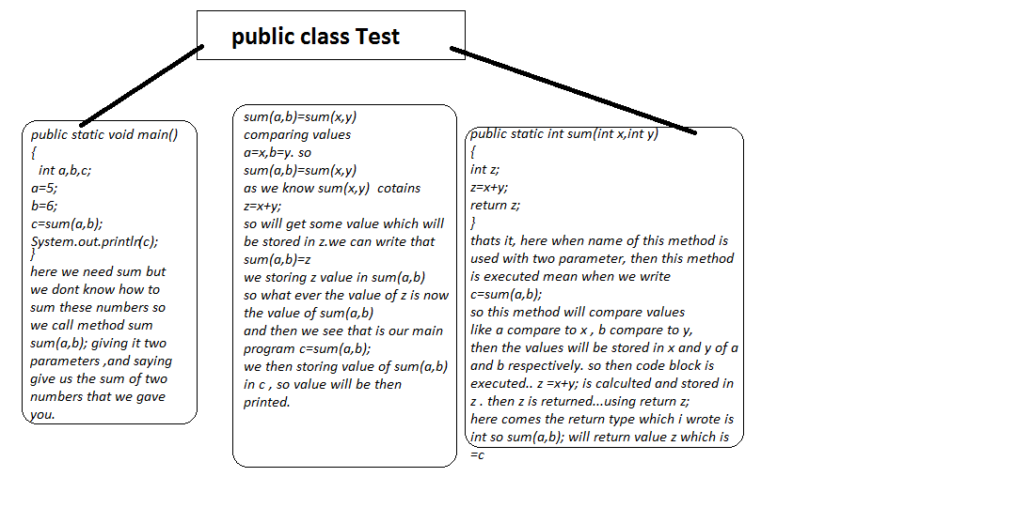 calling work…..

this is calling methods with parameters..

